Alkyl Halide Reaction from a Tertiary Alcohol
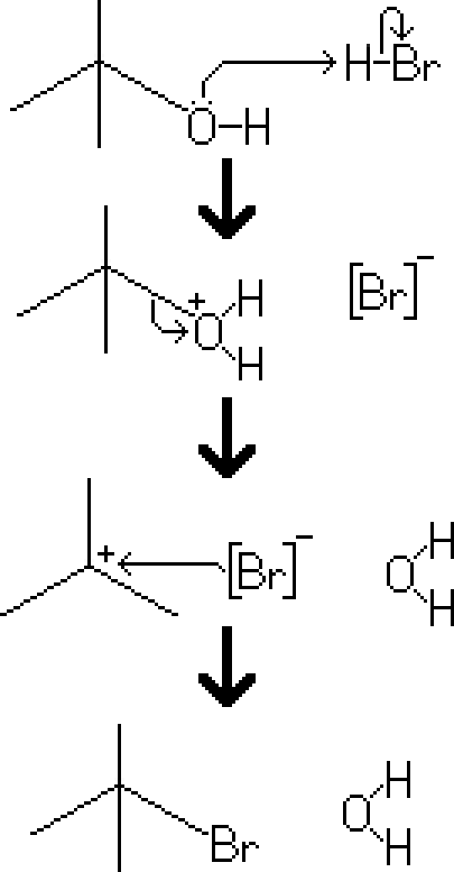
Reactants – Tertiary Alcohol, HBr
Products – Tertiary Alkyl Halide, Water
Electron Movement
- SN2 Reaction – The hydroxy of the alcohol is protonated, created a good leaving group. [H₂O] This allows the removal of water from the molecule, creating a carbocation. Finally, a negatively charged bromine ion attached to the molecule, creating a bromide.

Notes
- For primary and some secondary alcohols, an alkyl halide reaction would still occur, however the electron movement would follow the SN2 mechanism.
- Since the reaction is based on the SN1 mechanism, there are several conditions that may increase the rate of reaction
  - A substance in solution will have a higher rate of ionization if the solvent is polar protic.
  - For reactions involving alkyl halide reactants, halides with a larger radius will be an easier leaving group, and consequently will give the molecule a faster rate of ionization.
  - If the structure of the molecule allows for it, the reactant may restructure itself to lose steric strain (either with a hydride shift or a methyl shift)

